**HTML <strong> Tag**

Last Updated : 27 Aug, 2024

The **HTML <strong> Tag** is the parsed tag and is used to show the importance of the text. The content inside it is generally in **bold** format. The primary purpose of **<strong>**tag is to provide semantic meaning to the content, indicating its importance to both browsers and developers.

**Note**: This tag supports the [global attributes](https://www.geeksforgeeks.org/html-global-attributes/) and [event attributes](https://www.geeksforgeeks.org/html-event-attributes-complete-reference/) in HTML.

**Syntax**

<strong> Contents... </strong>

**Example 1:** This example illustrates the implementation of the HTML <strong> Tag.



1

<!DOCTYPE html>

2

<html>

3

​

4

<body>

5

<h1>

6

GeeksforGeeks

7

</h1>

8

<h2>

9

&lt;strong&gt; Tag

10

</h2>

11

12

<!-- HTML Strong Tag used here -->

13

<strong>

14

Welcome to geeksforGeeks!

15

</strong>

16

</body>

17

​

18

</html>

**Output:**

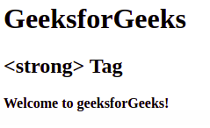

**Example 2:** In this example, we will use CSS property to set bold font weight.



1

<!DOCTYPE html>

2

<html>

3

​

4

<head>

5

<title>strong Tag</title>

6

<style>

7

body {

8

text-align: center;

9

}

10

​

11

h1 {

12

color: green;

13

}

14

​

15

.gfg {

16

font-weight: bold;

17

}

18

</style>

19

</head>

20

​

21

<body>

22

<h1>

23

GeeksforGeeks

24

</h1>

25

<h2>

26

font-weight: bold;

27

</h2>

28

<div class="gfg">

29

Welcome to geeksforGeeks!

30

</div>

31

</body>

32

​

33

</html>

**Output:**

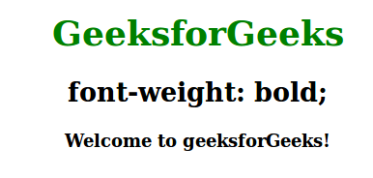

**Supported Browsers**

* [Google Chrome](https://www.geeksforgeeks.org/google-chrome-browser/)
* [Edge](https://www.geeksforgeeks.org/microsoft-edge-browser/)
* [Firefox](https://www.geeksforgeeks.org/mozilla-firefox-browser/)
* [Opera](https://www.geeksforgeeks.org/opera-browser/)
* [Safari](https://www.geeksforgeeks.org/apple-safari-browser/)

**HTML <strong> Tag – FAQs**